Creating An Order
(Sales Reps and Administrators)
Welcome to this how-to guide on creating orders as a sales rep or administrator using your XOLogic catalog. As a sales rep or administrator, your ability to create orders is critical to ensuring a seamless and efficient sales process. In this article, we will walk you through the step-by-step process of creating orders, from selecting the correct products to finalizing the sale. Whether you are new to XOLogic or a seasoned pro, this guide will provide you with the necessary knowledge and skills to successfully create orders and drive sales for your business. So, let's dive in!

In this article, we are going to go over:
- How to create an order without a customer account.
- How to create an order in an existing customer's account
- How to view the order as a customer
How to create an order without a customer account.
1) First log into the system as either an administrator or a sales representative. Click on “Catalog” on the left hand side of the screen and click the “Add” button next to the product that you would like to add to an estimate.
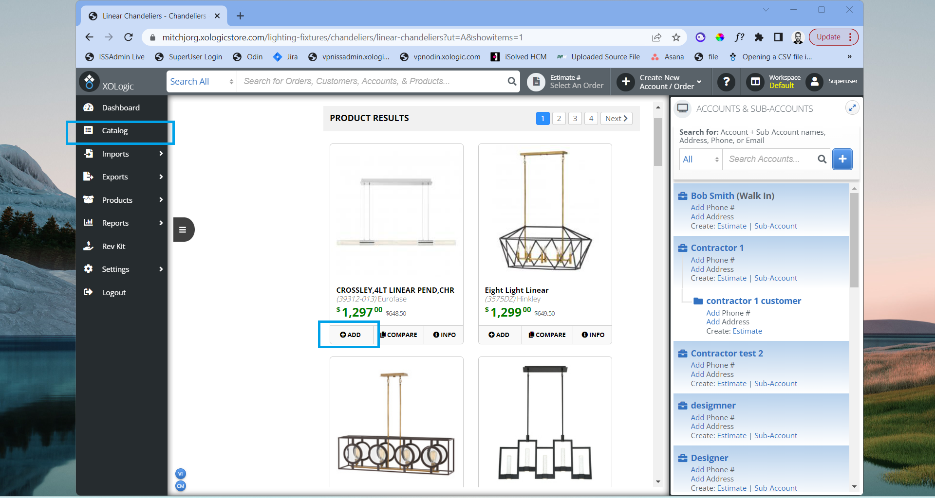
2) You will receive a popup where you can select whether you would like to add the item to a “New Or Existing Account” or “Enter Account Later”. For this example we are going to select “Enter Account Later”.
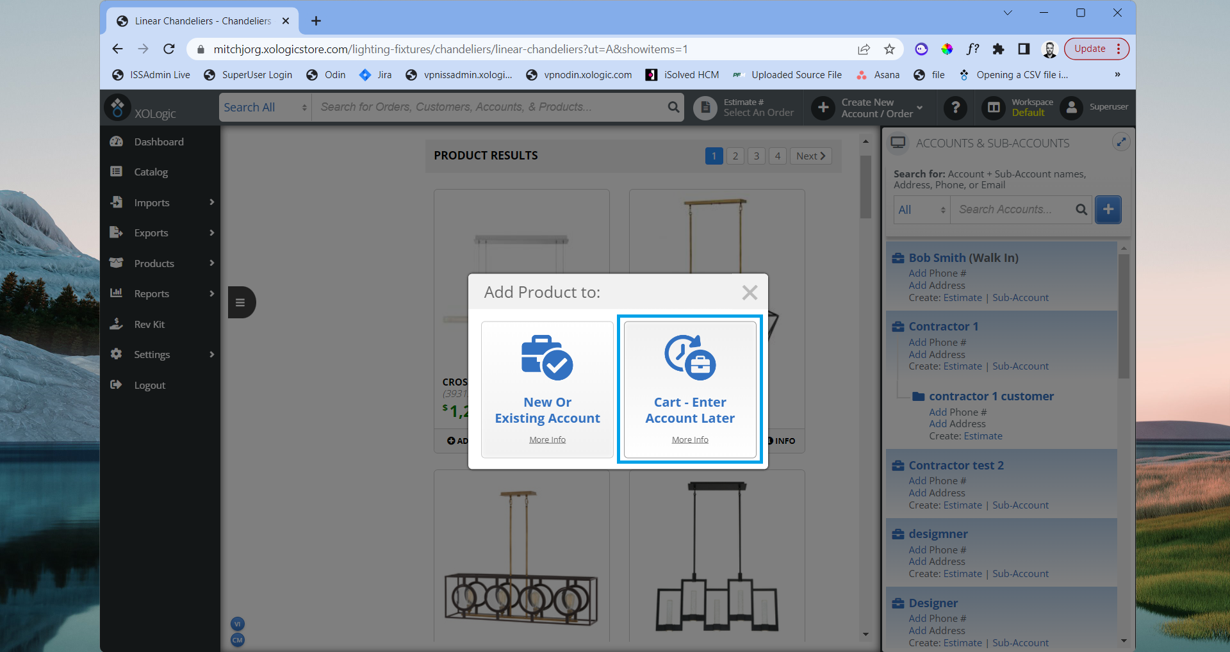
3) You will now see the items get added to the shopping cart on the right side of the screen. Since no account was selected before adding the product to the cart, the order will default to the walk-ins account.
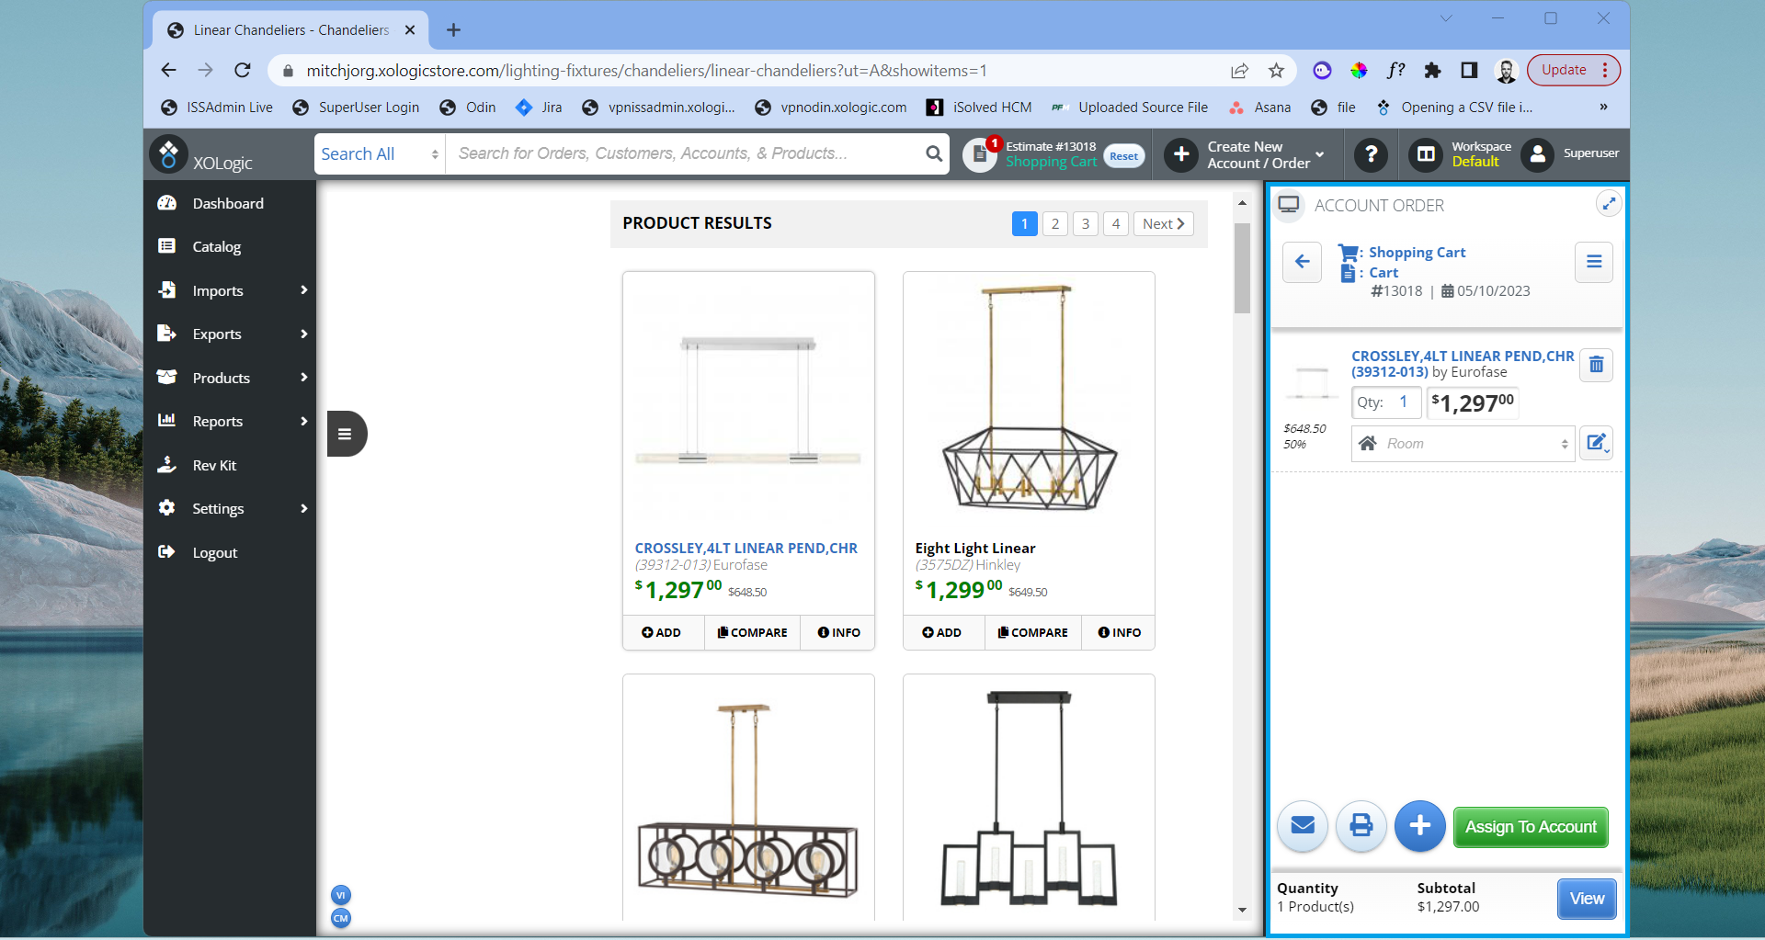
You can quickly add additional items together in a cart by clicking “Add” on additional items in the Catalog. You can also add additional items by selecting the blue “+” button in the bottom right corner and type the name or item number of the product you would like to add in the searchbox.
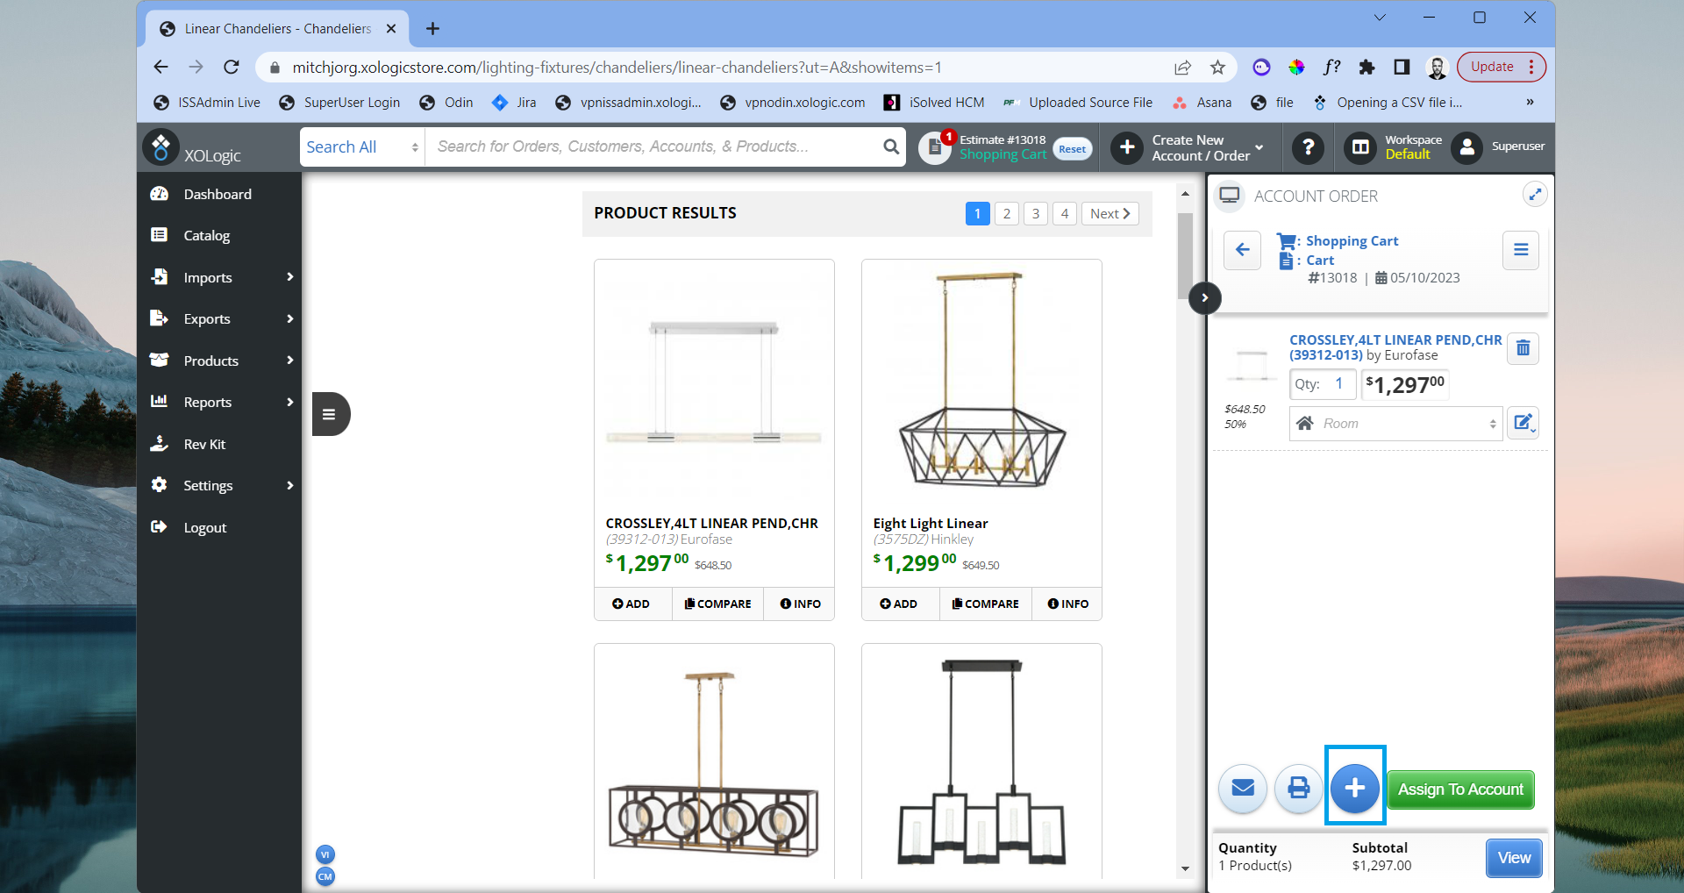
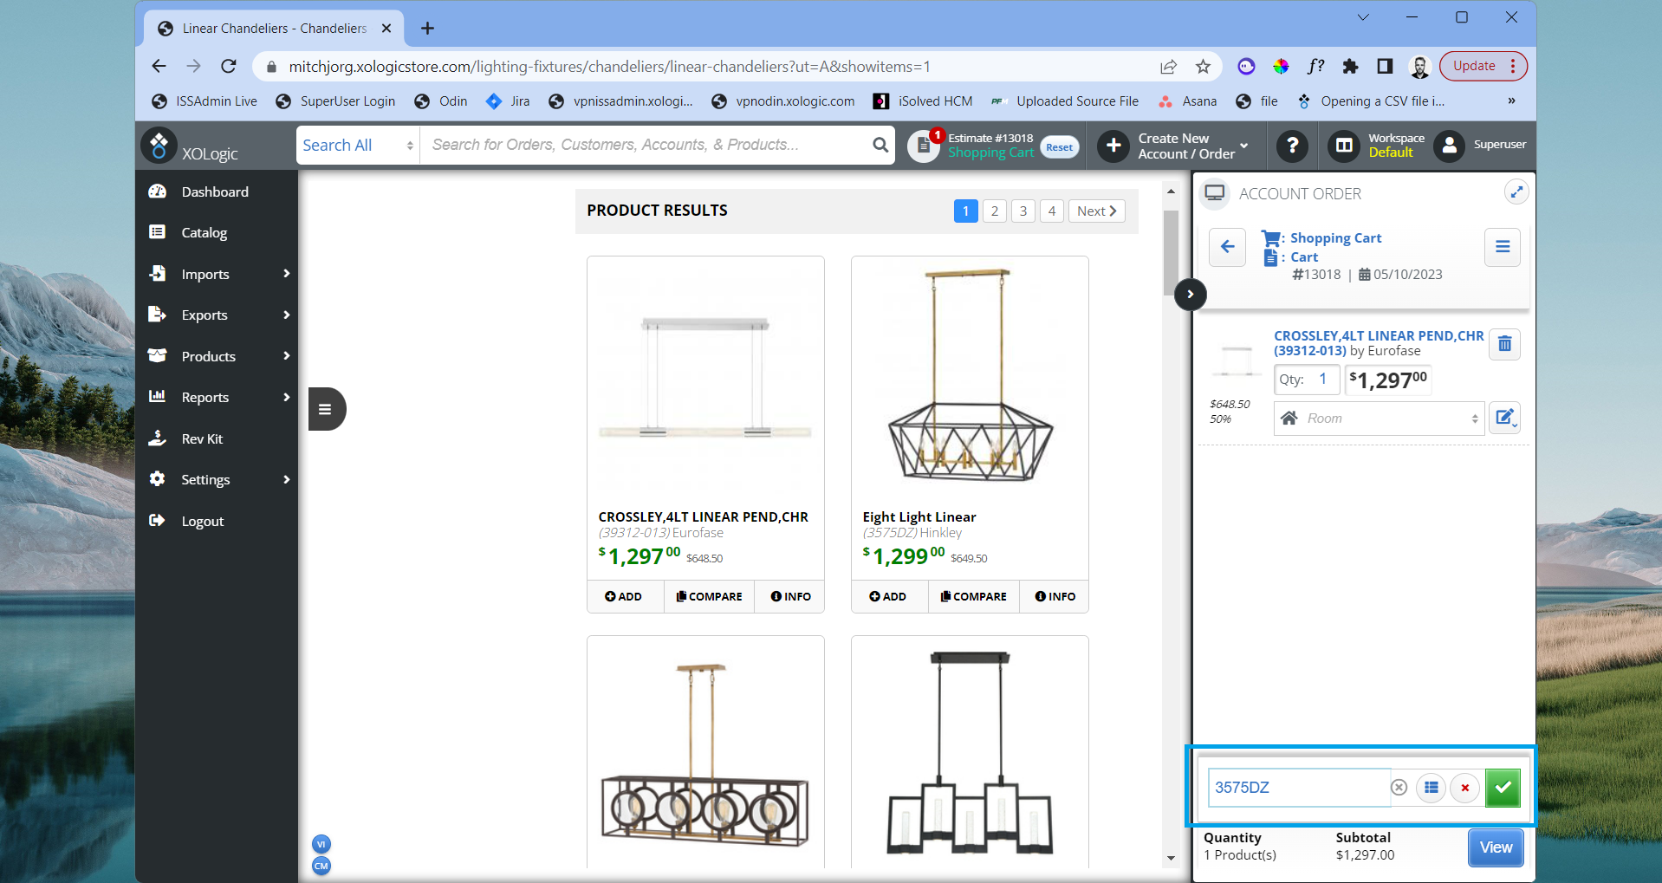
You can also email the estimate to the cusotmer or print the order by selecting the “Email” or “Print” buttons on the bottom right of the order.
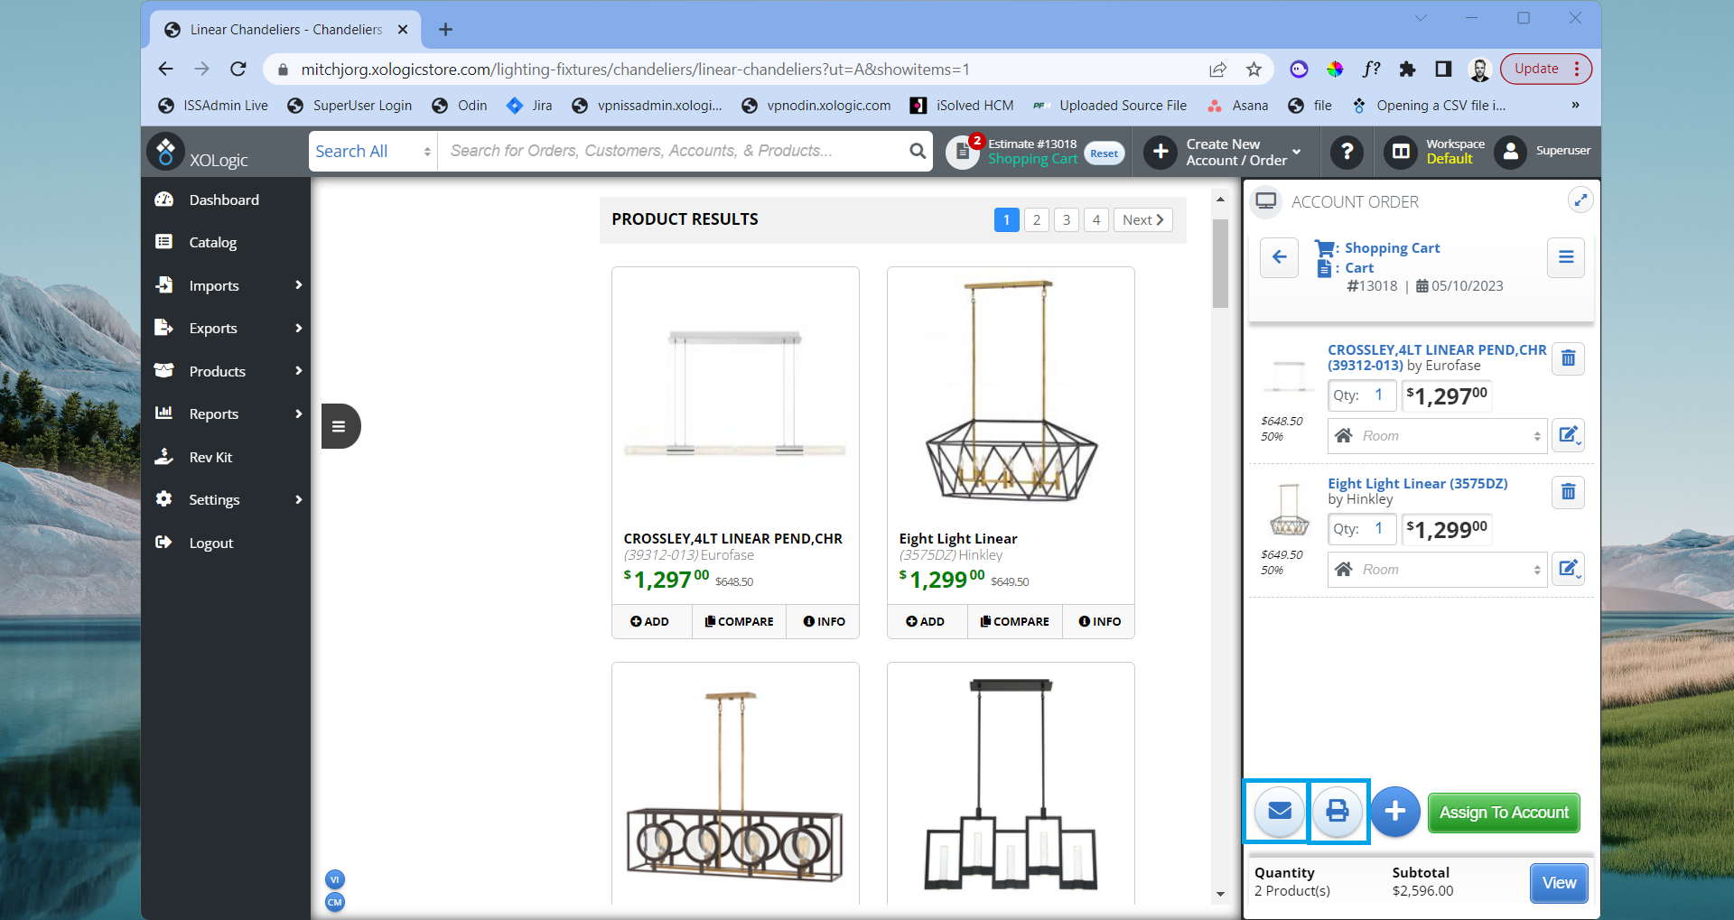

4) Click the “View” button at the bottom of the screen. This will open up a more detailed view of the order
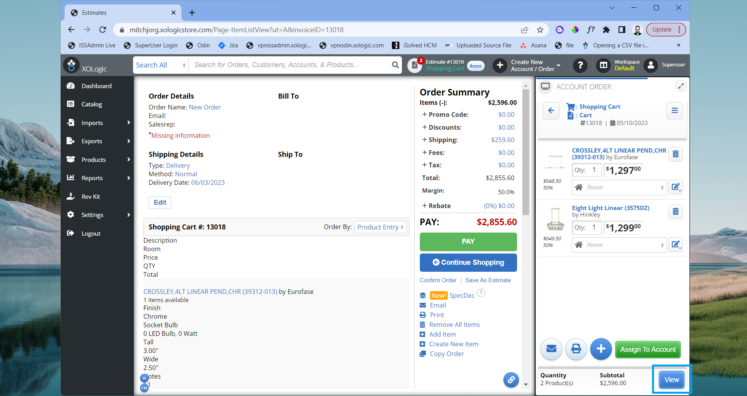

You can click the "Save As Estimate" link at the bottom right to assign the estimate to a customer's account once an account has been created. It is highly recommended to create a customer account to save and organize estimates and orders.
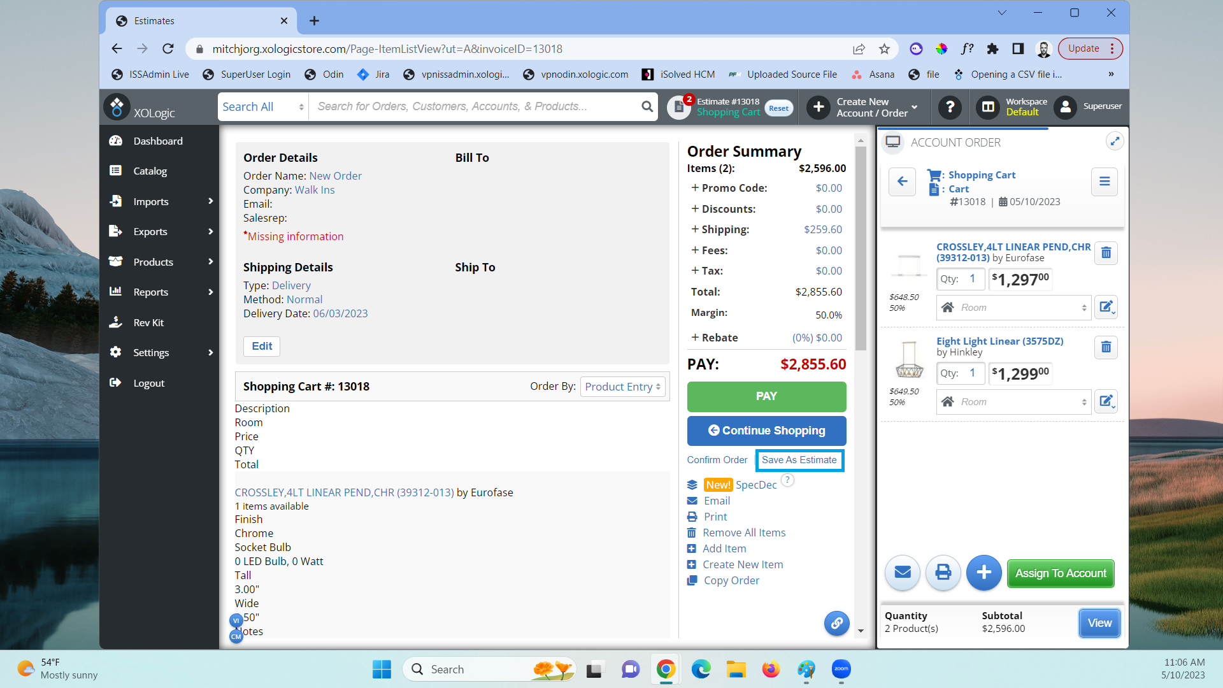
Great Job, you have successfully created an order without a customer account!

How to create an order if the customer's account has already been created.
1) On the right-hand side, you can search for a customer account in the search box or click on the Account or Subaccount name.
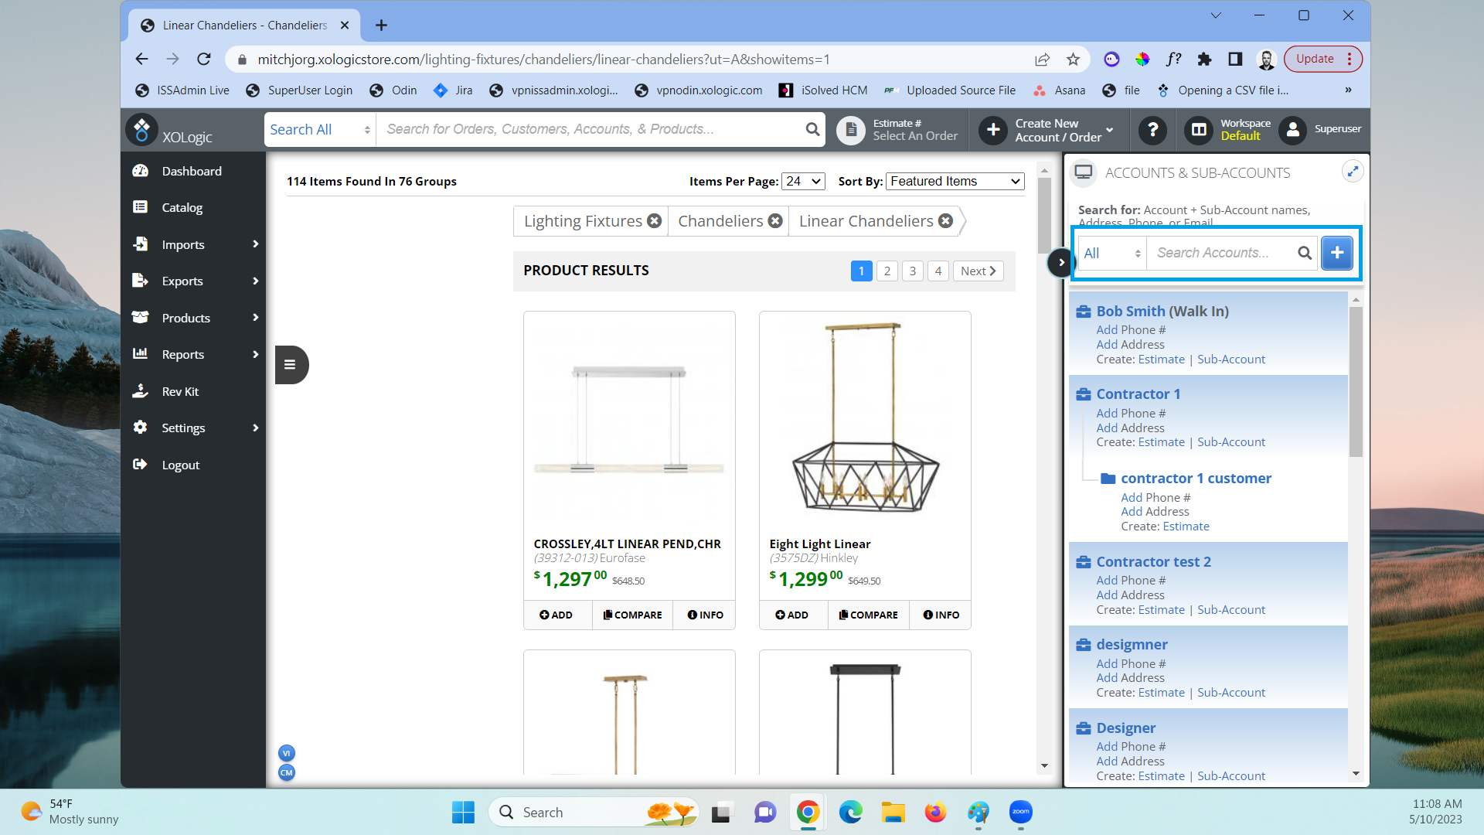

2) You can select an existing estimate or order in this section. To create a new estimate or order click the blue “plus button” at the top right of the screen
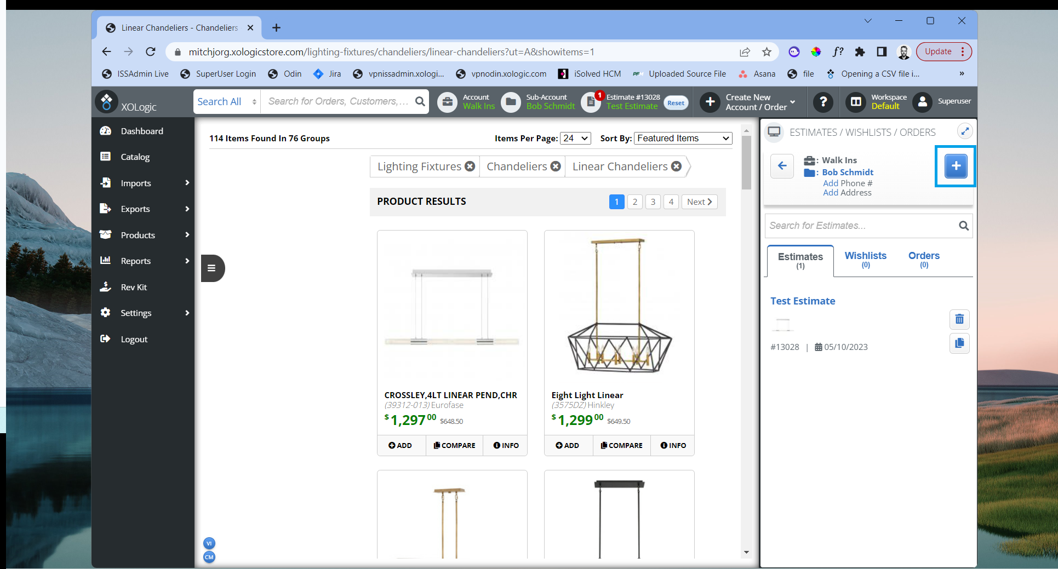
3) Type in a new estimate a name and click the green “Create” button to save.
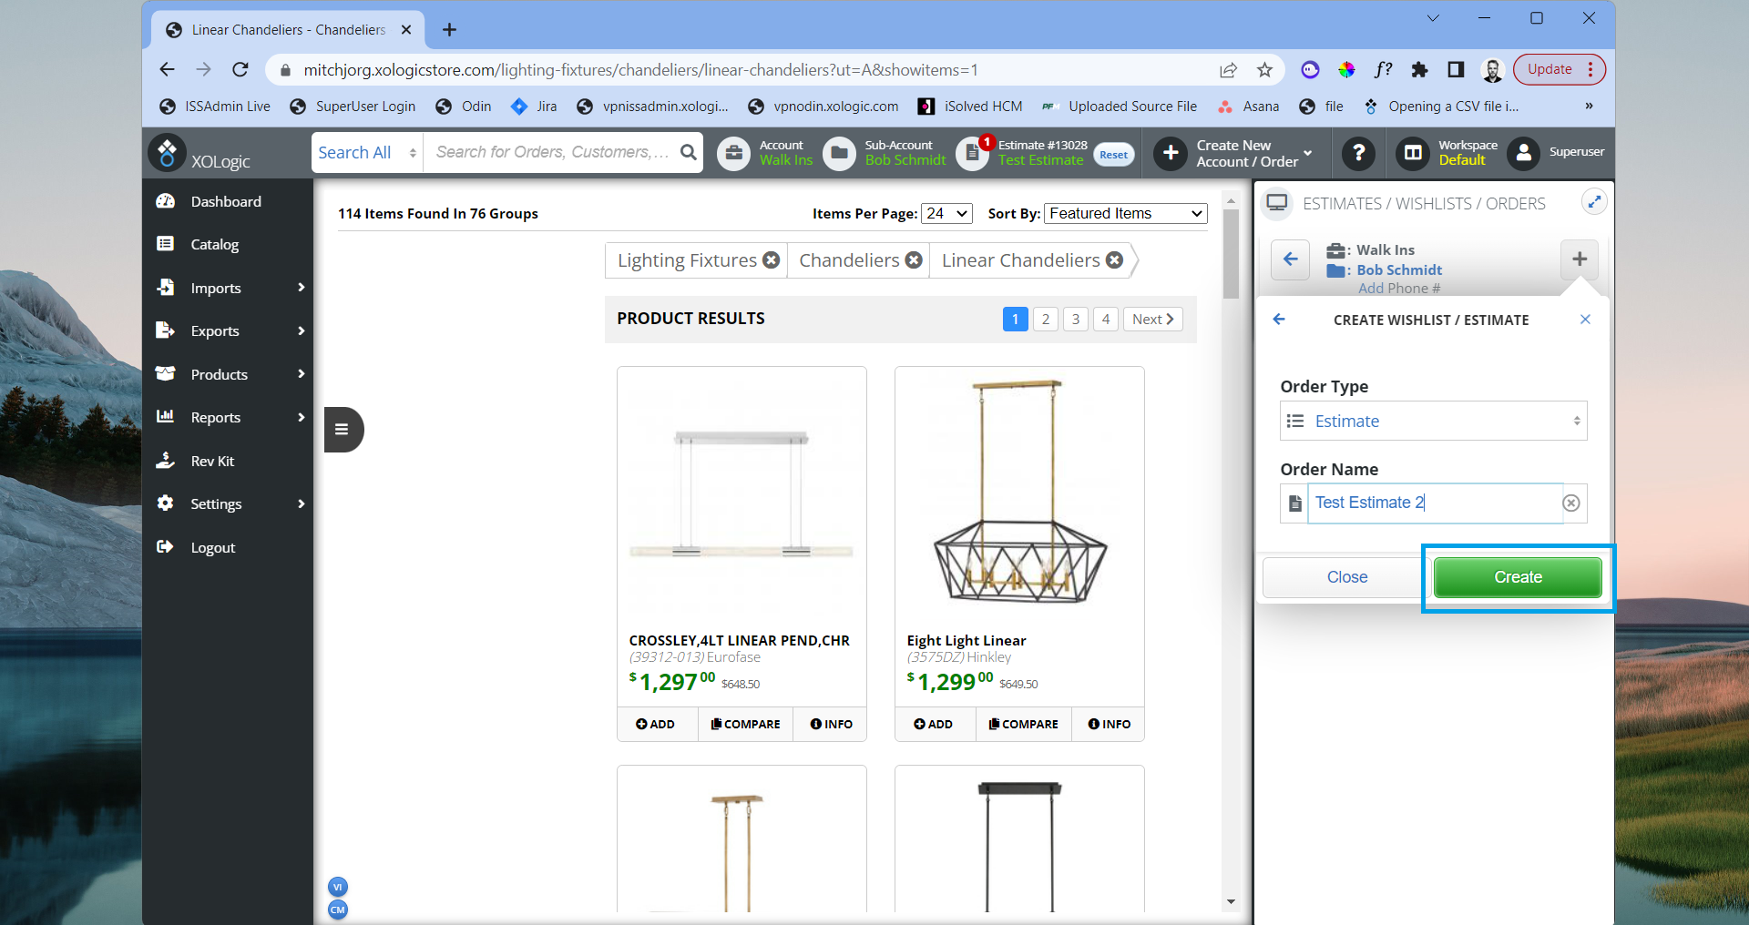

Once the estimate has been created, an estimate number will be generated. You can now see your order including customer name, order name, and estimate number.
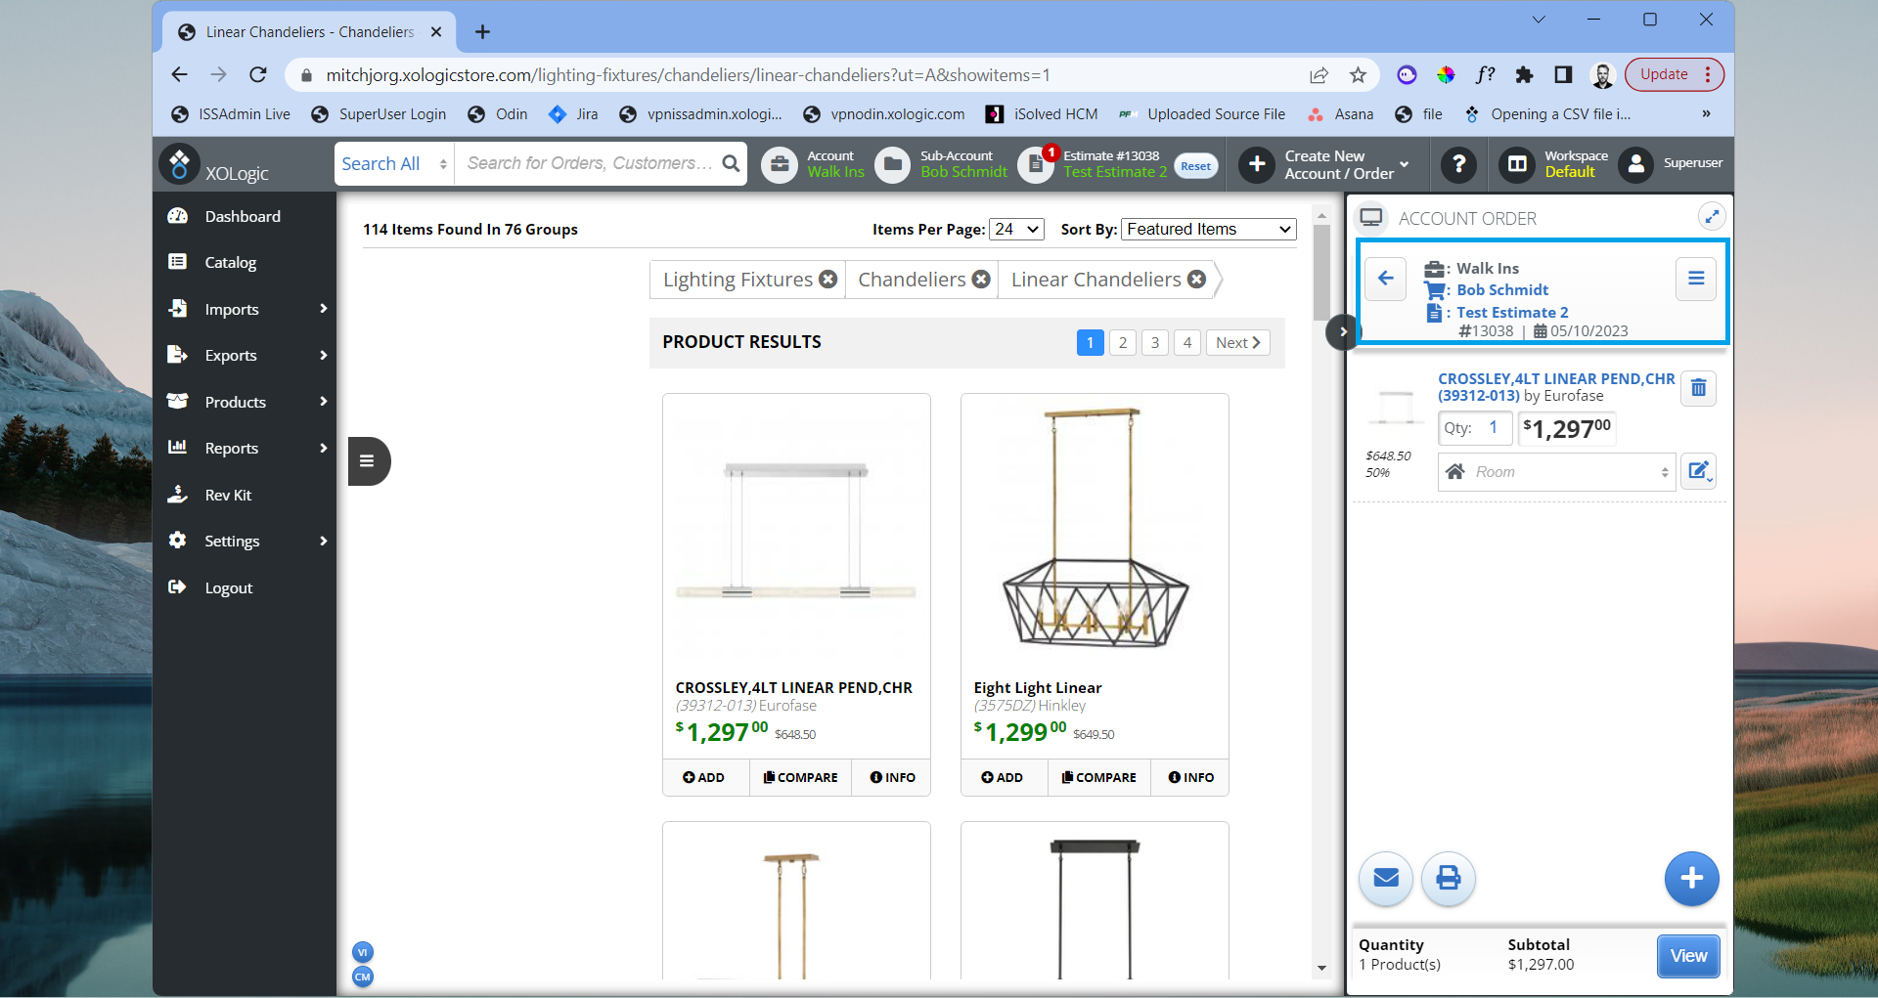
4) You can now add items to your order by clicking the blue “+” button in the bottom right hand corner or navigating to the “Catalog” section on left and clicking “Add” on the item details page.
You will see the item has now been added to the customers estimate on the right side of the screen
Great job you have successfully created an order in an existing customer's account!
How to view the order as a customer
Customers will be able to view this estimate by logging into their customer account and clicking on the dropdown at the top right of the screen and selecting “Estimates”.
1) Customers can select an estimate from the dropdown and click “View” to see the estimate in more detail.
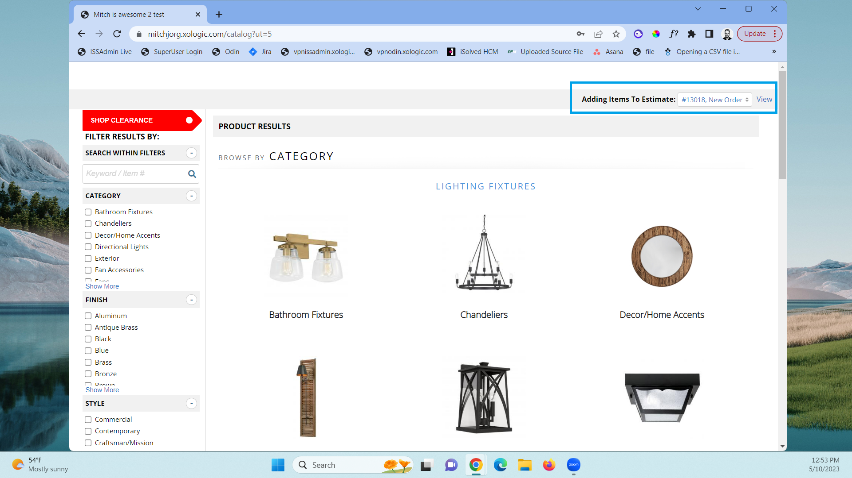
2) There is also the option to email, print, remove items, or add additional items to the estimate.
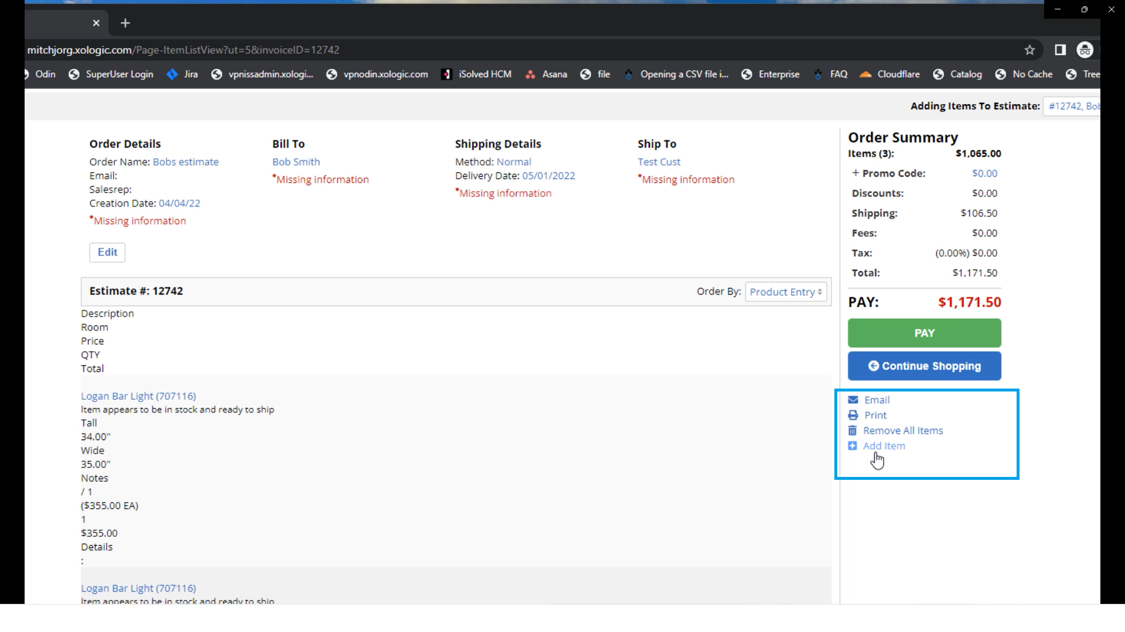
3) Once an estimate has been successfully built out to their personal preference, a customer can click on the “Pay” button to complete the order.
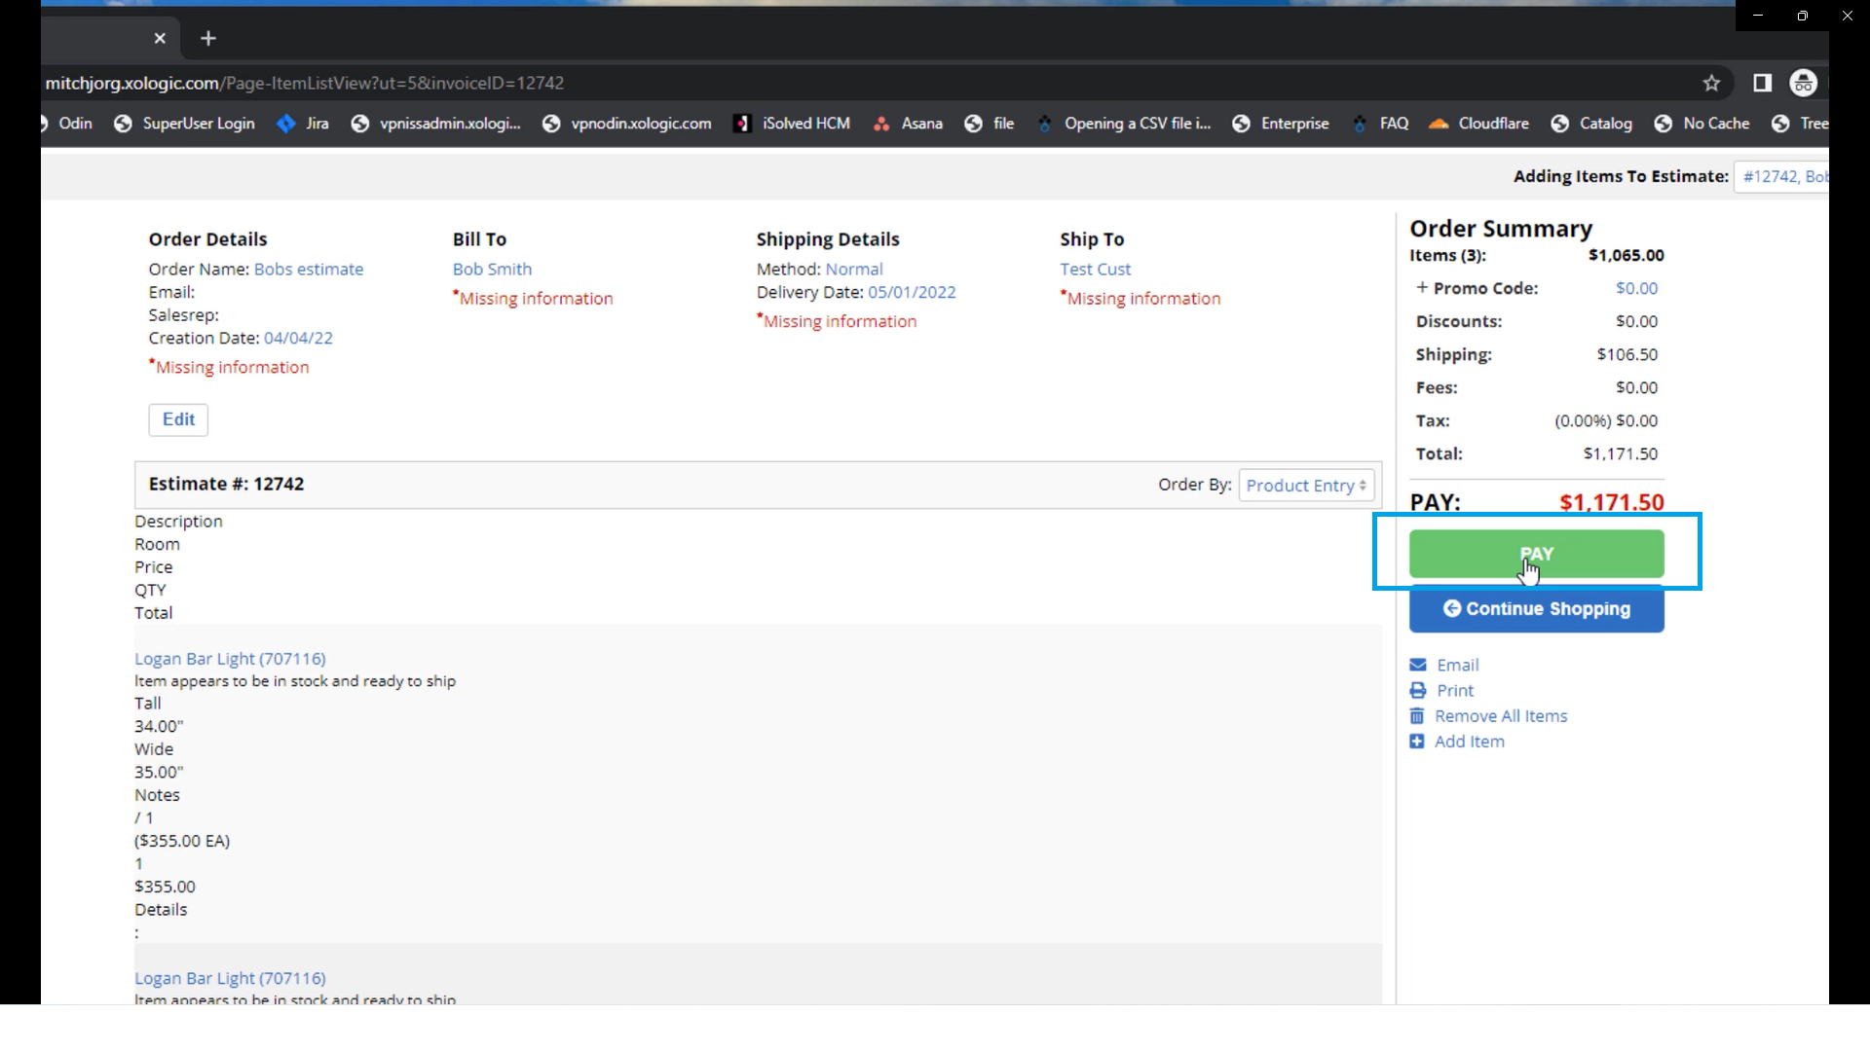
Great job! You have successfully learned How to create an order in an existing customer’s account, How to create an order in an existing customer’s account, and How to view the order as a customer. You now have the necessary knowledge and skills to successfully create orders and drive sales for your business!

